Architectures for Software Systems
Tactics for archiving Quality attributes
Reading Questions 3
Readings:
[Bass 03] Chapters 5, 13 (Tactics, Web case study)

Questions:

- What is tactic? Describe tactics to archive Availability or Performance quality attribute
- Consider a widely used Web site, such as Amazon or eBay. What tactics would you need to consider when choosing the architectural patterns or architectural strategies for meeting the performance requirements you enumerated in that question?
[1 point for grammar and overall quality]
- What is tactic?
A tactic provides a scheme for refining the elements of a software system and the relationship between them.
Tactics:
Are independent of a particular programming language and are independent of structure
Consist of finer granularity details than architectural patterns
Directly promote quality attribute properties
Can applies to various structures or ensembles to refine their quality attribute responses.
Tactics to archive Availability quality attributes
The goal of this tactic: will keep faults from becoming failures or at least bound the effects of the fault and make repair possible.
The following is tactics:
Fault detection: three widely used tactics for recognizing faults are ping/echo, heartbeat, and exceptions
- Ping/echo is not dependent upon structure but could be used several different kind of structures to improve availability.
- Heartbeat (dead man timer): one component emits a heartbeat message periodically and another component listens for it.The originating component is assumed to have failed if the heartbeat fails and a fault correction component is notified.
- Exceptions is one method for recognizing faults is to encounter an exception
Fault recovery:
- Voting is used to correct faulty operation of algorithms or failure of a processor and is often used in control systems.
- Active redundancy is often used in a client/server configuration where quick responses are necessary even when a fault occurs, the downtime of systems using this tactic is usually milliseconds since the backup is current and the only time to recover is the switching time
- Passive redundancy is used in control systems, often when the inputs come over communication channels or from sensors and have to be switched from the primary to the backup on failure. When a fault occurs, the system must first ensure that the backup state is sufficiently fresh before resuming services.
- Spare is often used as the standby client workstation, where the user can move when a failure occurs, it must be rebooted to the appropriate software configuration and have its state initialized.
- Shadow operation is used to make sure that failed component mimics the behavior of the working components before restoring it to service.
- Checkpoint/rollback is a recording of a consistent state created either periodically or in response to specific events
Fault prevention
- Removal from service: Removes a component of the system from operation to undergo some activities to prevent anticipated failures
- Transactions: The bundling of several sequential steps such that the entire bundle can be undone at once
- Process monitor: Monitors the state of health of a system process
Tactics to archive Performance quality attributes:
The goal of performance tactics is to generate a response to an event arriving at the system within some time constraint
Two basic contributors: resource consumption, blocked time (contention for resources, availability of resources, and dependency on other computation)
Resource demand
- Two characteristics: time between events in a stream, how much of a resource is consumed by each request
- Tactic:
  - Reduce resources required to process an event stream: increase computational efficiency, reduce computational overhead
  - Reduce resources required to process an event stream: increase computational efficiency, reduce computational overhead
  - Control use of resources: bound execution times, bound queue lengths
Resource management
- If the demand for resources isn’t controllable, they might be managed by these tactics:
  - Introduce concurrency: Processing different streams of events on different threads or by creating additional threads to process different sets of activities
  - Maintain multiple copies: Reduce the contention that would occur if all computations took place on a central server
  - Increase available resources: Faster processors, additional processors, additional memory, and faster networks all have the potential for reducing latency
Resource arbitration
- A scheduling policy has two parts: a priority assignment, dispatching
- Some common scheduling policies are:
  - First-in/First-out: all requests for resources as equal and satisfy them in turn
  - Fixed-priority scheduling: assigns each source of resource requests a particular priority and assigns the resources in that priority orders. Three common prioritization strategies are: semantic importance, deadline monotonic, and rate monotonic
  - Dynamic priority scheduling: round robin, earliest deadline first
  - Static scheduling: a scheduling strategy where the preemption points and the sequence of assignment to the resource are determined offline
(Reference from [Bass 03] Chapters 5)
- The statics would you need to consider
With a widely used Web site (Amazon or eBay), is a popular Web site will typically have tens of millions of "hits" per day, and users expect low latency from it. Customers will not tolerate the site simply refusing their requests. So when choosing the architectural patterns or architectural strategies for meeting the performance requirements, we need consider “A typical e-commerce system” to choose tactics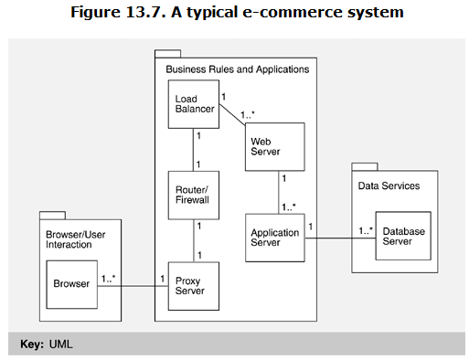
We need review each of the elements of ecommerce system to choose tactics:
- Proxy server: used to cache web pages from a web server. So it speeds up access to resources. Caches carry out the tactic of "multiple copies."
- Load balancing: distribute the "load" incoming HTTP and HTTPS requests among a pool of computers running Web servers. A load balancing will connect with many web servers. It simultaneous processing requirements, distribute workload evenly across two or more computers , network links, CPUs, hard drives, or other resources, in order to get optimal resource utilization, maximize throughput, minimize response time, and avoid overload. So load balancing follows from the tactic of "introducing physical concurrency”
- Web server: before this, web servers were typically single threaded. But modern versions are multithreaded. So it less susceptible to bottlenecks when a number of long-running HTTP or HTTPS requests arrive because other threads in the pool are still available to serve incoming requests. This is the performance tactic of "introduce concurrency."
- Can be accomplished by replacing existing servers with more powerful machines that will run more threads simultaneously.
- Application server: limiting the network traffic to performance-tier traffic the client server model improves the performance of large applications in heavy usage environments.
- Database server: In database have stored procedures. So they frequently use internal replication for performance; they may use caching for faster performance, save way of data.
Base on each of the elements of ecommerce system, we have tactics such as: multiple copies, introducing physical concurrency, introduce concurrency

